SSE 841 Capstone Project
Harnessing Smartsheet for Integrated EHS Management: BESCO Electric — UK Markey Cancer Center & Advanced Ambulatory Complex

Lawrence Lagat
Eastern Kentucky University-MS in Safety, Security & Emergency Management
SSE 841 Capstone
Dr. R
August 2026

Contents
1. The Safety Problem 4
2. The Solution: A Smartsheet-Based EHS System 5
Why Smartsheet 6
3. System Modules 7
Module 1: Safety & Compliance Dashboard 7
Module 2: Incident Log 11
Module 3: Site Infractions 12
Module 4: GC Notifications 13
Module 5: Training & Certification Log 14
Module 6: PPE Inventory 15
Module 7: Permit Log 16
Module 8: Corrective Action Tracker 17
Module 9: Scissor Lift Inspections 18
Module 10: PPE Budget Tracker 19
Module 11: Team Leader Attendance 20
4. Smartsheet Forms — How Field Data Gets Into the System 22
5. Implementation Plan 25
Phase 1: Get Approval and Set Up (Weeks 1–2) 25
Phase 2: Train the Team (Week 3) 25
Phase 3: Go Live (Week 4 Onward) 26
Phase 4: Keep Improving (Ongoing) 26
6. Expected Results 27
References 29
Appendices 30
Appendix 1: Automation for alerts 30
Appendix 2: Attachments can be added, such as certificates for individual rows 31
Appendix 3: Project 841 Workspace in Smartsheet 32

Harnessing Smartsheet for Integrated EHS Management: BESCO Electric — UK Markey Cancer Center & Advanced Ambulatory Complex

1. The Safety Problem
Construction is one of the most dangerous industries in the United States. In 2022, 1,075 construction workers were killed on the job — about 20% of all worker deaths in private industry (BLS, 2023). OSHA calls the four leading causes the "Fatal Four": falls, being struck by objects, electrocution, and being caught in or between equipment. Together, these account for more than 60% of all construction deaths (OSHA, 2023).
Electrical subcontractors are at even greater risk. They work at height, handle energized systems, operate heavy equipment like scissor lifts and forklifts, and work alongside other trades. Yet most electrical subcontractors do not have their own safety management system. They rely on the General Contractor's records for permits, training logs, and inspection documents. When something goes wrong, the subcontractor often has no independent paper trail to show.
Research backs this up. Specialty trade contractors — including electrical — have injury rates 30–40% higher than General Contractors on the same projects, largely because they lack their own safety systems (CPWR, 2022). Only 29% of specialty subcontractors use a dedicated safety software platform (JBKnowledge, 2022).
At BESCO Electric on the UK Markey Cancer Center & Advanced Ambulatory Complex Project in Lexington, Kentucky — this problem is real. BESCO has no independent digital EHS system. Permits, certifications, inspections, infractions, and corrective actions are tracked informally or through Walsh Construction's (GC) systems. If OSHA walked on site tomorrow, BESCO would struggle to produce its own records.

2. The Solution: A Smartsheet-Based EHS System
This project builds a complete, ready-to-use EHS management system for BESCO Electric using Smartsheet — a cloud-based platform that works on any phone, tablet, or computer. The system has ten modules, each tracking a different area of site safety. Every module has its own data entry form that workers can fill out from their phones, in real time, on the job site.
The system was chosen over expensive enterprise EHS platforms like Procore, Intelex, or Cority because Smartsheet does the same core job at a fraction of the cost, with no IT setup required.

Why Smartsheet
Factor | Detail
Cost | Pro plan: $9/member/month | Business plan: $19/member/month | Enterprise: $39/member/month (all billed yearly). Recommended: Business plan at $19/member/month for 5 licensed users = approximately $1,140/year — vs. $6,000–$15,000/year for enterprise EHS platforms such as Procore, Intelex, or Cority.
Mobile Forms | Each module has a dedicated Smartsheet Form accessible via smartphone from a QR code or shared link — no Smartsheet account required to submit. Field personnel submit data in real time from the job site.
Automations | Built-in automation rules send email alerts for expiring certifications, overdue corrective actions, and scissor lift FAIL results. Reduces reliance on manual follow-up.
Dashboard | Native Dashboard builder provides live KPI tiles and charts aggregating data from all nine modules simultaneously. This gives management a single-screen EHS performance view.
Scalability | The Workspace can be duplicated for additional BESCO projects with no redesign, making the system a reusable organizational asset beyond the Project.

3. System Modules
The system has ten modules. Each module is described below with a screenshot showing its layout and simulated data. The screenshots show how the system looks and behaves when real data is entered.

Module 1: Safety & Compliance Dashboard
The Dashboard is the first thing a manager sees when they open the system. It shows live numbers and charts pulled automatically from all other modules. There is no manual updating — the Dashboard refreshes as new data comes in.
It displays seven key safety numbers at a glance: total incidents this month, open infractions, GC notifications, expired training records, PPE items low on stock, open corrective actions, and scissor lift inspection failures. Below the numbers are nine charts showing trends by location, type, and assigned person.

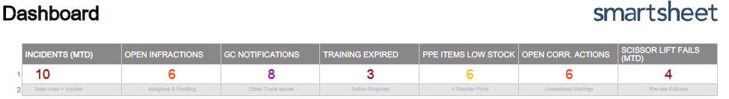
Figure 1: Live Dashboard showing KPI summary tiles and safety performance numbers. All values update automatically as data is entered into any module.

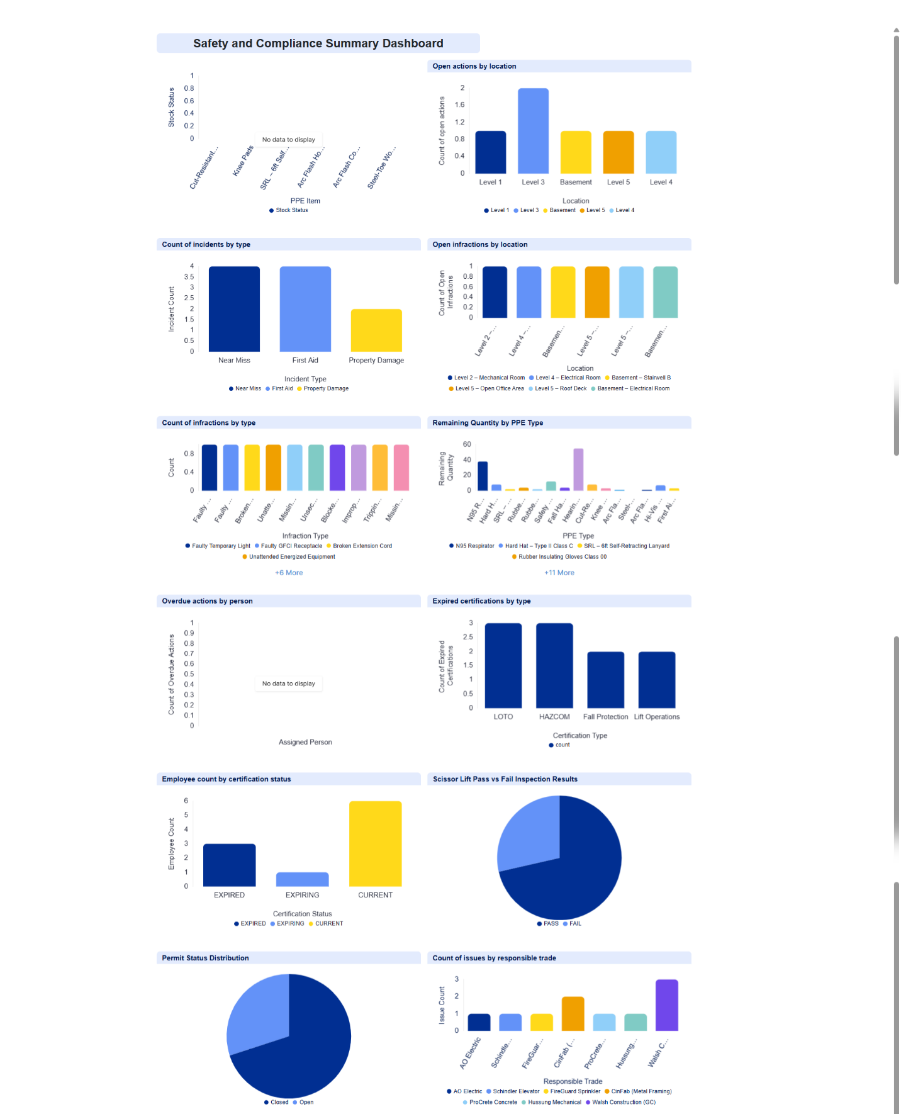
Figure 2: Live Dashboard showing KPI summary tiles and safety performance charts. All values update automatically as data is entered into any module.

Module 2: Incident Log
This module records every safety incident on the job site — near misses, first aid cases, recordable injuries, property damage, and illness. For each incident, the system captures what happened, where, who was involved, what caused it, what was done immediately, and what follow-up is needed.
The module also tracks whether the incident resulted in lost time, whether it is OSHA recordable, and whether the investigation has been completed. This gives BESCO a complete, independent incident record that does not rely on the GC's system.

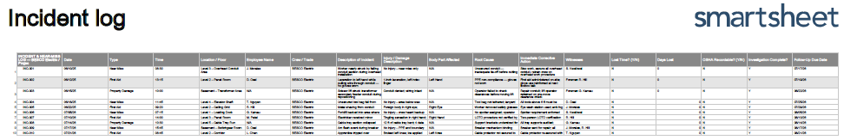
Figure 3: Incident Log showing simulated entries across Near Miss, First Aid, and Property Damage categories with root cause, corrective action, and follow-up fields.

Module 3: Site Infractions
This module tracks electrical and safety problems found during daily inspections and site walkthroughs. Examples include faulty GFCI outlets, broken extension cords, temporary lights that are not working, unattended energized equipment, and blocked egress paths.
Each infraction is assigned to a specific person with a due date for fixing it. The status shows whether it is Open or Closed. Overdue items are flagged automatically so nothing gets forgotten.

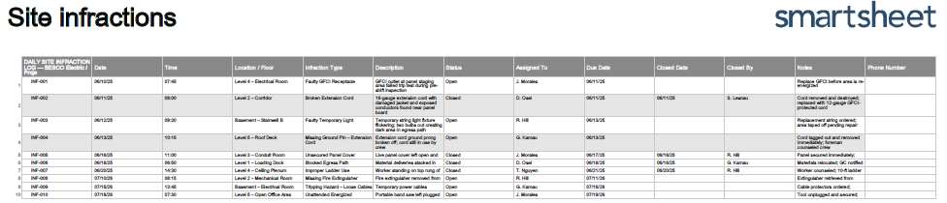
Figure 4: Site Infractions log showing infraction type, location, assigned person, due date, and Open/Closed status with conditional color formatting.

Module 4: GC Notifications
When another trade causes a problem that affects BESCO's work, this module logs it and helps communicate it to Walsh Construction. Examples include mechanical piping blocking a conduit run, drywall hung before BESCO finished rough-in, or water flooding a BESCO electrical room.
Each entry records the responsible trade, the problem, the impact on BESCO, the priority level, and the GC's response.

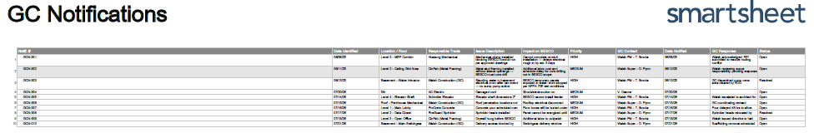
Figure 5: GC Notifications log showing other-trade issues with priority, GC contact, and the auto-generated email draft populated from the selected row.

Module 5: Training & Certification Log
This module tracks safety certifications for every BESCO crew member — LOTO, HAZCOM, Fall Protection, and Lift Operations. It shows the date each certification was completed and when it expires. The status column automatically shows CURRENT, EXPIRING (within 30 days), or EXPIRED.
When a certification is within 30 days of expiring, Smartsheet automatically sends an email alert to the Safety Manager. This means no one has to manually check dates — the system catches expiring certifications before they become a compliance problem.

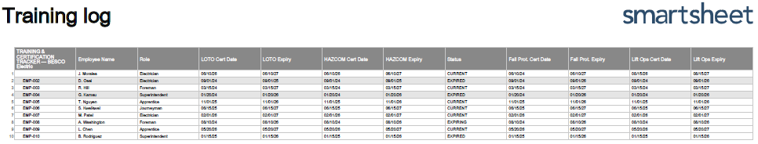
Figure 6: Training Log showing employee certifications with CURRENT (green), EXPIRING (yellow), and EXPIRED (red) status flags and automated expiry alert logic.

Module 6: PPE Inventory
This module tracks every PPE item in the BESCO storeroom — how much was received, how much has been issued to workers, and how much is left. Each item has a reorder point. When stock drops to or below that level, the status automatically changes to LOW, signaling that a reorder is needed.
A separate issuance log below the inventory tracks which items were given to which employee and on what date. This creates a clear accountability record for every piece of PPE.

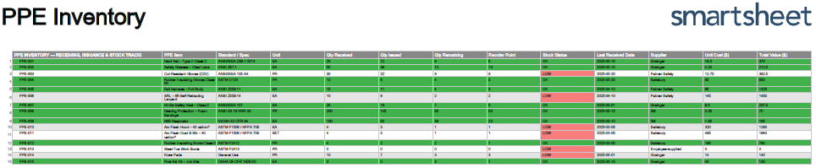
Figure 7: PPE Inventory showing received, issued, and remaining quantities with OK/LOW stock status and a separate employee issuance log.

Module 7: Permit Log
This module gives BESCO its own independent record of every permit issued on the project — Hot Work, Confined Space, and Excavation. Right now, BESCO relies entirely on Walsh Construction's permit system. If there is ever a question about whether a permit was in place, BESCO has no independent proof.
This module fixes that. Each entry records the permit type, location, work description, who issued it, who approved it, start and expiry times, fire watch or attendant assigned, and current status.

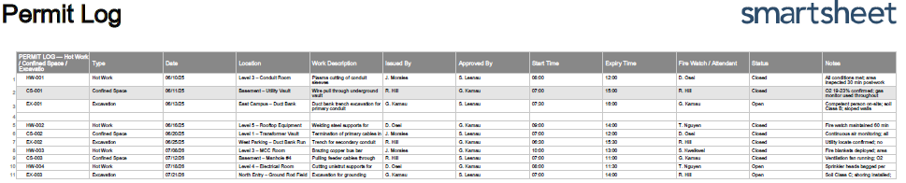
Figure 8: Permit Log showing permit entries with type, location, issuer, approver, times, fire watch/attendant, and Open/Closed status.

Module 8: Corrective Action Tracker
This module is the central place to track all open safety problems — wherever they came from. An infraction, an incident finding, a failed scissor lift inspection, or a GC notification can all generate a corrective action here. Each one is assigned to a person with a due date.
The system automatically calculates how many days an item is overdue. When something goes past its due date, Smartsheet sends an automatic alert to the assigned person and the Safety Manager. Nothing can quietly sit open and forgotten.

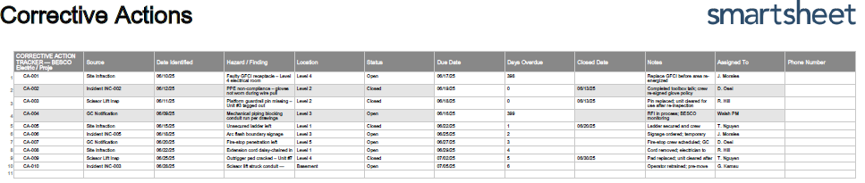
Figure 9: Corrective Action Tracker showing findings from multiple sources, assigned persons, due dates, days overdue, and Open/Closed status with color coding.

Module 9: Scissor Lift Inspections
Before any scissor lift is used, the operator completes a seven-point pre-use inspection: tires and wheels, controls, emergency stop, platform and guardrails, hydraulics, and horn and lights. The result is either PASS or FAIL.
If the lift fails, the entry is automatically flagged and a corrective action is created. The lift should be tagged out until the problem is fixed. This module creates a date-stamped inspection record for every lift on site — something OSHA can ask for during an inspection.

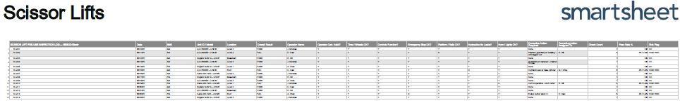
Figure 10: Scissor Lift Inspection log showing unit ID, operator, seven-point checklist results, PASS/FAIL outcome, and corrective action assignments for failed inspections.

Module 10: PPE Budget Tracker
This module tracks every dollar spent on PPE and safety equipment against a set budget. At the top, it shows total budget, amount spent, amount remaining, percentage used, and projected year-end spend based on the current rate of spending.
This matters because many projects overspend on PPE without realizing it until the end. This module gives the Safety Manager and Project Manager an early warning if the budget is heading toward an overrun, while there is still time to act.
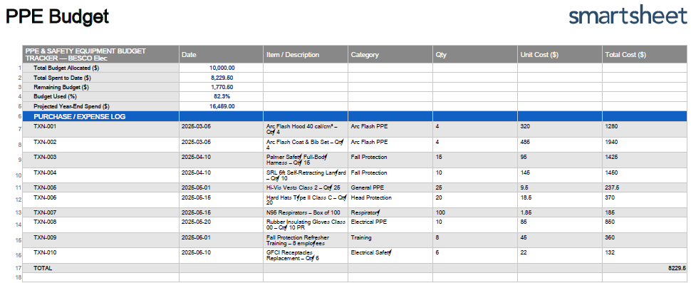
Figure 11: PPE Budget Tracker showing transaction log, total budget, amount spent, remaining balance, percentage used, and projected year-end spend.

Module 11: Team Leader Attendance
This module tracks daily attendance for Foremen, Superintendents, and the Safety Manager. Knowing who is on site each day matters for two reasons: it helps confirm that each crew has proper supervision, and it creates a record that can be used to verify presence during incidents or inspections.
Each team leader logs in at the start of their shift using the Attendance Form on their phone. The form captures their name, role, shift date, status (Present, Absent, Late, or Half Day), and time in. If someone is absent, the form also captures the reason and who is covering their crew. The Safety Manager reviews attendance each morning as part of the pre-shift routine.

Field | What It Captures
Employee Name & Role | Foreman, Superintendent, or Safety Manager
Date | Auto-populated from form submission date
Status | Present / Absent / Late / Half Day — dropdown selection
Time In | Time the team leader arrived on site

Absent Reason | Sick, Personal, Injury Leave, Off Day — if not present
Coverage | Name of person covering the absent team leader's crew
Notes | Any additional context for the shift

This module will be added to the system before formal deployment. The screenshot placeholder below will be replaced with the actual Smartsheet view once the module is built.

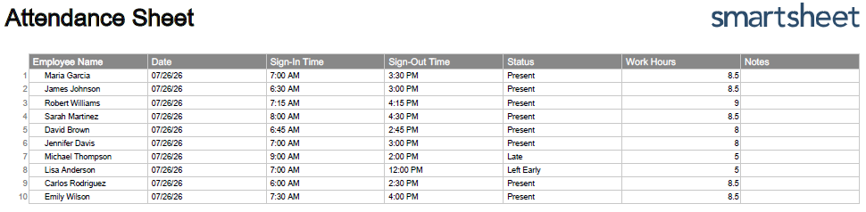
Figure 11: Attendance module showing daily team leader sign-in status, time in, absent reasons, and coverage assignments.

4. Smartsheet Forms — How Field Data Gets Into the System
Every module has its own Smartsheet Form. These forms are how workers put data into the system from the field — without needing to log into Smartsheet or sit at a computer.
Each form works like this: the worker opens a link on their phone, fills in the fields, and hits submit. The data goes directly into the right module sheet automatically. Forms include dropdown menus and required fields to make sure the data is complete and consistent.

Form | Who Submits It / When
Incident Report Form | Foreman or Safety Rep — submitted immediately after any incident or near miss
Site Infraction Form | Anyone doing a pre-shift walkthrough — submitted when a hazard is found
GC Notification Form | Foreman or Superintendent — submitted when another trade creates a problem for BESCO
Training & Certification Form | Safety Manager — submitted when a certification is verified or renewed
PPE Inventory Form | Safety Manager— submitted when PPE is received or issued
Permit Log Form | Permit issuer — submitted before any hot work, confined space, or excavation work begins
Corrective Action Form | Foreman or Safety Manager— submitted when a new corrective action is identified from any source
Scissor Lift Inspection Form | Lift operator — submitted before the first use of each lift each shift
Attendance Form | Each Foreman/Superintendent — submitted at the start of every shift
PPE Budget Form | Safety Manager — submitted after any PPE purchase or training expense

Forms are shared two ways: a QR code posted in the site trailer, gang boxes, scissor lifts and PPE storeroom, and a direct link sent through the BESCO project group chat. No Smartsheet account is needed to submit a form.

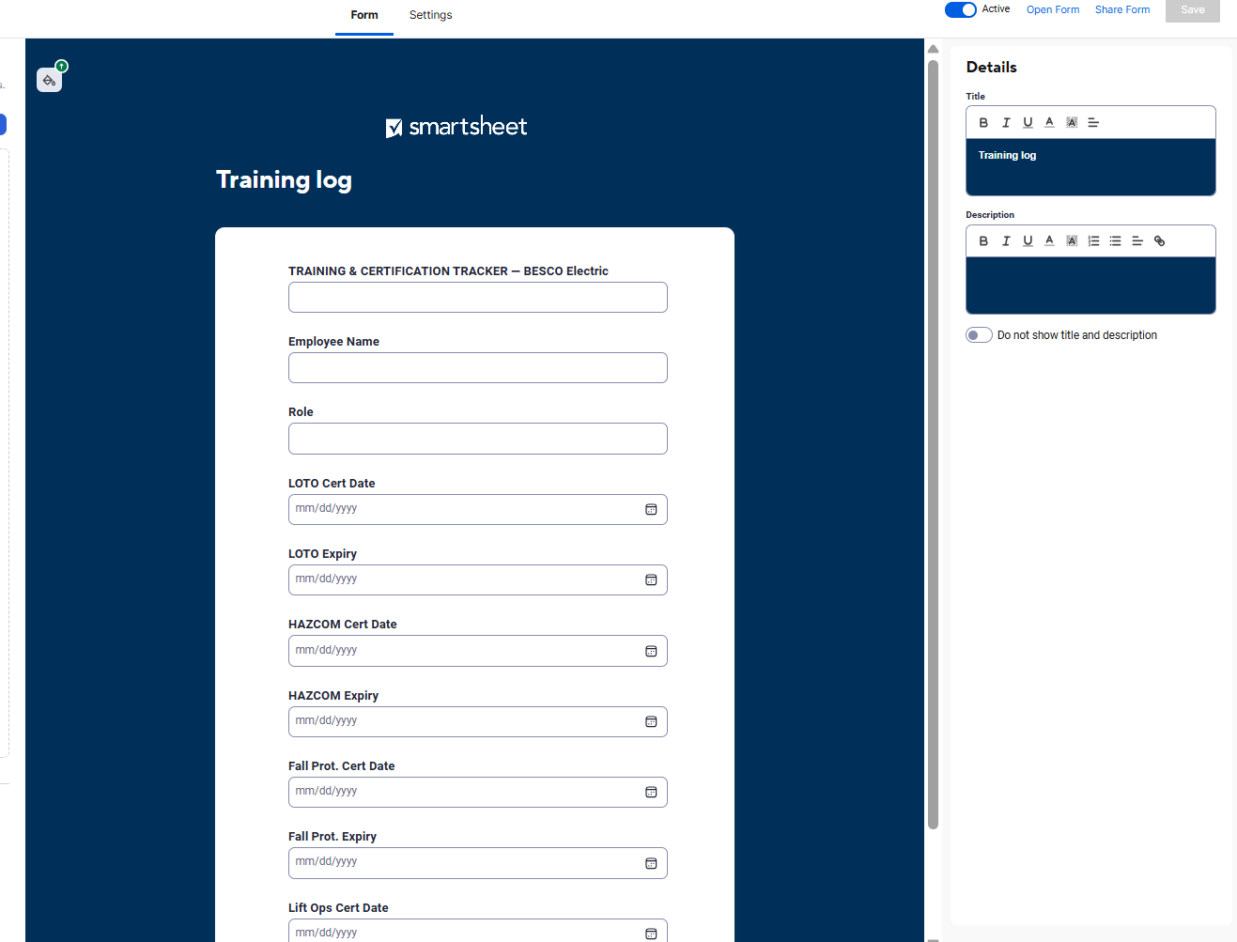
Figure 13: Example Form for training log

5. Implementation Plan
The system is designed and simulated. The steps below describe how it will be put into real use on the job site.

Phase 1: Get Approval and Set Up (Weeks 1–2)
- Present the system to the BESCO Corporate Safety Director, Project Manager and Superintendent and get approval to deploy
- Subscribe to the Smartsheet Business Plan ($19/user/month, billed yearly) — recommended for unlimited automations and unlimited free form submitters
- Enter the actual employee roster and verified certification dates; remove all simulated data
- Turn on automation rules: 30-day training expiry alerts, overdue corrective action reminders, scissor lift FAIL notifications
- Build and test the Attendance module before go-live

Phase 2: Train the Team (Week 3)
- Run a 30–45 minute toolbox training with all Foremen and Superintendents
- Cover what the system does, how to submit each form, how to read the Dashboard, and what to do when an item is flagged
- Print and post QR codes for all forms in the site trailer, gang boxes, scissor lifts, and storeroom
- Share form links through the project group chat so every team leader has them on their phone
- Assign the Safety Manager as system administrator — responsible for weekly Dashboard review and data quality

Phase 3: Go Live (Week 4 Onward)
- Team leaders submit forms in real time as events happen during their shift
- Safety Manager reviews the Dashboard every week and escalates any overdue items to the Superintendent
- Project Manager reviews the Dashboard monthly for trends and budget status
- All GC communication generated from the GC Notifications module — no ad hoc emails

Phase 4: Keep Improving (Ongoing)
- Every quarter, review the system and add anything new the project needs — new infraction types, PPE items, or permit categories
- Use Dashboard trends to make smarter decisions — for example, if Level 3 keeps showing up as the top infraction location, target it for extra inspections
- When BESCO starts a new project, copy the entire system and update the project-specific fields — no rebuilding
- After the first 30 days, collect feedback from Foremen on what is easy and what is not, and make adjustments

6. Expected Results
Once the system is running on the job site, these are the improvements BESCO should see:
Area | What Should Improve
Incident Records | Every incident documented with cause, corrective action, and follow-up — BESCO has its own record, not just the GC's
Training Compliance | No more expired certifications going unnoticed — the system sends alerts 30 days before anything expires
Permit Control | BESCO has its own permit records, independent of Walsh Construction
Infraction Closure | All site hazards assigned to someone with a deadline — target: fixed within 48 hours for electrical hazards
Scissor Lift Safety | Every lift checked before use; any FAIL creates an automatic corrective action and tags the unit out
Corrective Actions | All findings tracked to closure; overdue items trigger automatic alerts — target: closed within 7 days
PPE Stock | Low-stock alerts go out before PPE runs out — workers always have what they need
GC Communication | Every other-trade issue formally logged and communicated — no more verbal-only complaints that get forgotten
Budget Control | Live view of PPE spending vs. budget — catches overruns early, while there is still time to adjust
Attendance | Daily record of who is supervising each crew — supports incident investigations and supervisory accountability
OSHA Readiness | Complete, date-stamped digital records accessible from any device at any time — ready for any inspection

Studies show that construction companies using structured digital EHS systems have 28% fewer recordable injuries on average compared to those using paper systems (Pinto et al., 2020). Companies with formal safety management programs — including permit control, training tracking, and inspection records — experience 50% lower lost-time injury rates than industry averages (OSHA, 2021).

References
Bureau of Labor Statistics (BLS). (2022). National census of fatal occupational injuries in 2021. U.S. Department of Labor. https://www.bls.gov/news.release/cfoi.nr0.htm
Bureau of Labor Statistics (BLS). (2023). National census of fatal occupational injuries in 2022. U.S. Department of Labor. https://www.bls.gov/news.release/cfoi.nr0.htm
CPWR — The Center for Construction Research and Training. (2022). The construction chart book (6th ed.). CPWR.
JBKnowledge. (2022). Construction technology report. JBKnowledge Inc.
Occupational Safety and Health Administration (OSHA). (2021). Voluntary Protection Programs: Program summary data. U.S. Department of Labor.
Occupational Safety and Health Administration (OSHA). (2023). Construction: The Fatal Four. U.S. Department of Labor. https://www.osha.gov/construction/fatalfour
Pinto, A., Nunes, I. L., & Ribeiro, R. A. (2020). Occupational risk assessment in construction industry. Safety Science, 125, 104618. https://doi.org/10.1016/j.ssci.2020.104618
Smartsheet. (2026). Pricing plans. https://www.smartsheet.com/pricing
Swuste, P., Frijters, A., & Guldenmund, F. (2021). Is it possible to influence the safety performance of small contractors working at large sites? Journal of Safety Research, 76, 237–247.

Appendices

Appendix 1: Automation for alerts

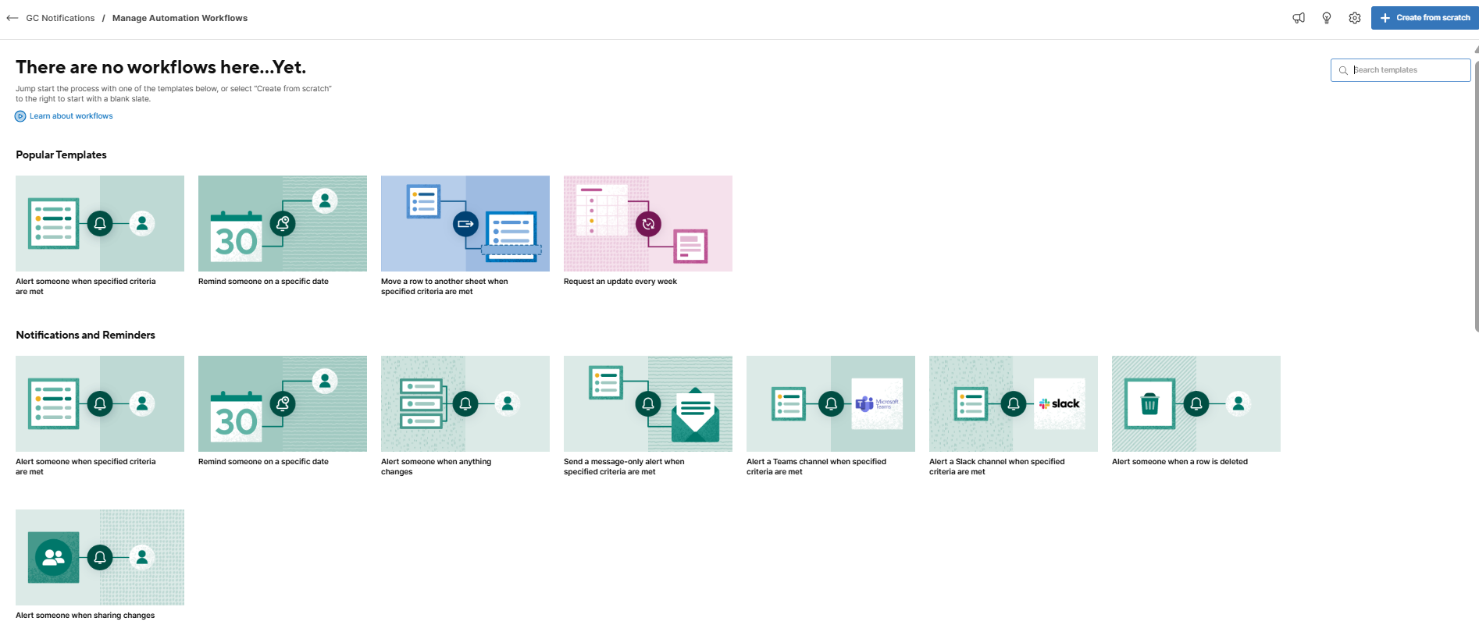

Appendix 2: Attachments can be added, such as certificates for individual rows

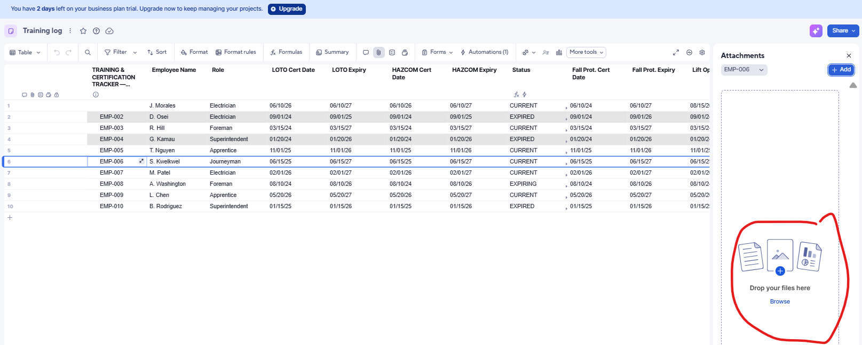

Appendix 3: Project 841 Workspace in Smartsheet
